**Internet dan Aplikasinya**

**TUGAS 6 : Analisa Koneksi Antar Jaringan**



**Oleh :**

Nama : Joahnes Yogtan Wicaksono Raharja

NIM : 215314105

**PROGRAM STUDI INFORMATIKA**

**FAKULTAS SAINS DAN TEKNOLOGI**

**UNIVERSITAS SANATA DHARMA**

**YOGYAKARTA**

**2022**

1. **Screenshot Topologi**

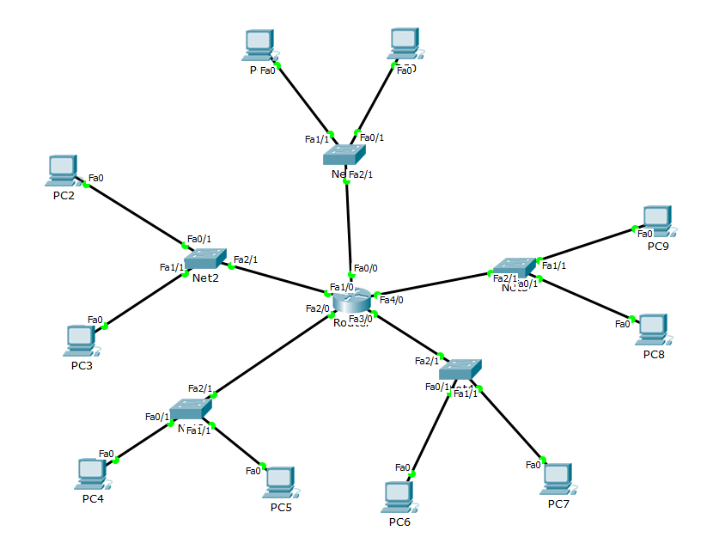

1. **Tugas**
2. **Tabel**

|  |  |  |  |  |
| --- | --- | --- | --- | --- |
| Connection | Device | MAC Add | IP Add | Net Add |
| Switch 0 | Router | 00AA.1111.1111 | 172.16.105.126 | 255.255.255.128 |
|  | PC 0 | 0000.4105.4105 | 172.16.105.1 | 255.255.255.128 |
|  | PC 1 | 0001.4105.4105 | 172.16.105.2 | 255.255.255.128 |
| Switch 1 | Router | 00AA.2222.2222 | 172.17.105.190 | 255.255.255.192 |
|  | PC 2 | 0002.4105.4105 | 172.17.105.129 | 255.255.255.192 |
|  | PC 3 | 0003.4105.4105 | 172.17.105.130 | 255.255.255.192 |
| Switch 2 | Router | 00AA.3333.3333 | 172.18.105.62 | 255.255.255.240 |
|  | PC 4 | 0004.4105.4105 | 172.18.105.49 | 255.255.255.240 |
|  | PC 5 | 0005.4105.4105 | 172.18.105.50 | 255.255.255.240 |
| Switch 3 | Router | 00AA.4444.4444 | 172.19.105.126 | 255.255.255.192 |
|  | PC 6 | 0006.4105.4105 | 172.19.105.65 | 255.255.255.192 |
|  | PC 7 | 0007.4105.4105 | 172.19.105.66 | 255.255.255.192 |
| Switch 4 | Router | 00AA.5555.5555 | 172.20.105.30 | 255.255.255.240 |
|  | PC 8 | 0008.4105.4105 | 172.20.105.17 | 255.255.255.240 |
|  | PC 9 | 0009.4105.4105 | 172.20.105.18 | 255.255.255.240 |

1. **Percobaan**

* PC 0 ke PC 1 (Satu Network) dan catat :
  + ARP yang dibuat oleh PC 0

|  |  |  |  |
| --- | --- | --- | --- |
| Dest MAC | Source MAC | Source IP | Dest IP |
| FFFF.FFFF.FFFF | 0000.4105.4105 | 172.16.105.1 | 172.16.105.2 |

* + ICMP yang dibuat oleh PC 0

|  |  |  |  |
| --- | --- | --- | --- |
| Dest MAC | Source MAC | Source IP | Dest IP |
| 0001.4105.4105 | 0000.4105.4105 | 172.16.105.1 | 172.16.105.2 |

* + ICMP yang diterima oleh PC 1

|  |  |  |  |
| --- | --- | --- | --- |
| Dest MAC | Source MAC | Source IP | Dest IP |
| 0001.4105.4105 | 0000.4105.4105 | 172.16.105.1 | 172.16.105.2 |

* PC 1 ke PC 0 (Satu Network) dan catat :
  + ARP yang dibuat oleh PC 1

|  |  |  |  |
| --- | --- | --- | --- |
| Dest MAC | Source MAC | Source IP | Dest IP |
| FFFF.FFFF.FFFF | 0001.4105.4105 | 172.16.105.2 | 172.16.105.1 |

* + ICMP yang dibuat oleh PC 1

|  |  |  |  |
| --- | --- | --- | --- |
| Dest MAC | Source MAC | Source IP | Dest IP |
| 0000.4105.4105 | 0001.4105.4105 | 172.16.105.2 | 172.16.105.1 |

* + ICMP yang diterima oleh PC 0

|  |  |  |  |
| --- | --- | --- | --- |
| Dest MAC | Source MAC | Source IP | Dest IP |
| 0000.4105.4105 | 0001.4105.4105 | 172.16.105.2 | 172.16.105.1 |

* PC 0 ke Ruter dan catat :
  + ARP yang dibuat oleh PC 0

|  |  |  |  |
| --- | --- | --- | --- |
| Dest MAC | Source MAC | Source IP | Dest IP |
| FFFF.FFFF.FFFF | 0000.4105.4105 | 172.16.105.1 | 172.16.105.126 |

* + ICMP yang dibuat oleh PC 0

|  |  |  |  |
| --- | --- | --- | --- |
| Dest MAC | Source MAC | Source IP | Dest IP |
| 00AA.1111.1111 | 0000.4105.4105 | 172.16.105.1 | 172.16.105.126 |

* + ICMP yang diterima oleh Router

|  |  |  |  |
| --- | --- | --- | --- |
| Dest MAC | Source MAC | Source IP | Dest IP |
| 00AA.1111.1111 | 0000.4105.4105 | 172.16.105.1 | 172.16.105.126 |

* PC 2 ke Router dan catat :
  + ARP yang dibuat oleh PC 2

|  |  |  |  |
| --- | --- | --- | --- |
| Dest MAC | Source MAC | Source IP | Dest IP |
| FFFF.FFFF.FFFF | 0002.4105.4105 | 172.17.105.129 | 172.17.105.190 |

* + ICMP yang dibuat oleh PC 2

|  |  |  |  |
| --- | --- | --- | --- |
| Dest MAC | Source MAC | Source IP | Dest IP |
| 00.AA.2222.2222 | 0002.4105.4105 | 172.17.105.129 | 172.17.105.190 |

* + ICMP yang diterima oleh Router

|  |  |  |  |
| --- | --- | --- | --- |
| Dest MAC | Source MAC | Source IP | Dest IP |
| 00.AA.2222.2222 | 0002.4105.4105 | 172.17.105.129 | 172.17.105.190 |

* PC 0 ke PC 2 (Antar Network) dan catat :
  + ARP yang dibuat oleh PC 0

|  |  |  |  |
| --- | --- | --- | --- |
| Dest MAC | Source MAC | Source IP | Dest IP |
| FFFF.FFFF.FFFF | 0000.4105.4105 | 172.16.105.1 | 172.16.105.126 |

* + ICMP yang dibuat oleh PC 0

|  |  |  |  |
| --- | --- | --- | --- |
| Dest MAC | Source MAC | Source IP | Dest IP |
| 00AA.1111.1111 | 0000.4105.4105 | 172.16.105.1 | 172.17.105.129 |

* + ICMP yang diterima oleh PC 2

|  |  |  |  |
| --- | --- | --- | --- |
| Dest MAC | Source MAC | Source IP | Dest IP |
| 0002.4105.4105 | 00AA.1111.1111 | 172.16.105.1 | 172.17.105.129 |

* PC 1 ke Ruter dan catat :
  + ARP yang dibuat oleh PC 0

|  |  |  |  |
| --- | --- | --- | --- |
| Dest MAC | Source MAC | Source IP | Dest IP |
| FFFF.FFFF.FFFF | 0001.4105.4105 | 172.16.105.2 | 172.16.105.126 |

* + ICMP yang dibuat oleh PC 0

|  |  |  |  |
| --- | --- | --- | --- |
| Dest MAC | Source MAC | Source IP | Dest IP |
|  |  |  |  |
|  |  |  |  |

* + ICMP yang diterima oleh Router

|  |  |  |  |
| --- | --- | --- | --- |
| Dest MAC | Source MAC | Source IP | Dest IP |
| 00AA.1111.1111 | 0001.4105.4105 | 172.16.105.2 | 172.16.105.126 |

* PC 3 ke Router dan catat :
  + ARP yang dibuat oleh PC 2

|  |  |  |  |
| --- | --- | --- | --- |
| Dest MAC | Source MAC | Source IP | Dest IP |
| FFFF.FFFF.FFFF | 0003.4105.4105 | 172.17.105.130 | 172.17.105.190 |

* + ICMP yang dibuat oleh PC 2

|  |  |  |  |
| --- | --- | --- | --- |
| Dest MAC | Source MAC | Source IP | Dest IP |
|  |  |  |  |

* + ICMP yang diterima oleh Router

|  |  |  |  |
| --- | --- | --- | --- |
| Dest MAC | Source MAC | Source IP | Dest IP |
| 00.AA.2222.2222 | 0003.4105.4105 | 172.17.105.130 | 172.17.105.190 |

* PC 1 ke PC 3 (Antar Network) dan catat :
  + ARP yang dibuat oleh PC 0

|  |  |  |  |
| --- | --- | --- | --- |
| Dest MAC | Source MAC | Source IP | Dest IP |
| FFFF.FFFF.FFFF | 0001.4105.4105 | 172.16.105.2 | 172.16.105.126 |

* + ICMP yang dibuat oleh PC 0

|  |  |  |  |
| --- | --- | --- | --- |
| Dest MAC | Source MAC | Source IP | Dest IP |
|  |  |  |  |

* + ICMP yang diterima oleh PC 3

|  |  |  |  |
| --- | --- | --- | --- |
| Dest MAC | Source MAC | Source IP | Dest IP |
| 0003.4105.4105 | 00.AA.2222.2222 | 172.16.105.2 | 172.16.105.130 |

**C. Kesimpulan**

Apa yang terjadi ketika komunikasi dalam Satu Network dan Antar Network?

**JAWAB :**

Menurut saya perbedaanya terletak pada Dest MAC dan Dest IP nya. Kita dapat melihat bahwa pada satu network Dest MAC dikirim ke MAC add komputer sedangkan di antar network Dest MAC dikirim ke MAC add routernya. Begitu juga dengan Dest Ip harus menyesuaikan ip komputer yang akan dituju biar dapat membedakan networknya.